**PROJECT MANAGEMENT**

**ABSTRACT**

Managing and controlling the final year projects of students using manual or traditional process is a very tedious job. The main aim of this project is to create an automated system for managing all the activities of projects. Project management system is a system for managing, controlling, monitoring the final year projects of students. It is a web-based portal which is useful for students, project coordinator and project guide.

**INTRODUCTION**

**1.1 About the Project**

In today’s world, nobody takes an initiative to look for notices which are displayed on the notice boards. Many students miss the information about some important notices and updates related to their final year projects. Also, the students are not able to keep track of their project related activities. It becomes very easy if all the details and updates of the project from guides and coordinator are readily available for the students.

The main objectives of the project are:

* + It ensures the structure of hierarchy and accountability that facilitates guidance and support to all members.
  + It facilitates communication and collaboration.
  + It ensures that there are assessments, quality checks and reviews throughout the project development.

**1.2 Purpose**

To facilitate their students at their best will. They try to provide each facility, students have to deal with. The purpose of this application is to provide ease to students and to supervisors during the whole supervision and development. The application will save time for students and supervisors. Despite so distant from each other with the help of this application, they both can be connected

**1.3 Scope**

The scope of this project is to Students and Supervisors will login into the application. Students can see all their group members and profiles of supervisors to choose from according to their specializations and the nature of the project. This application will aid both students and supervisors in the whole process of final year project evaluation.

**WORKING OF THE SYSTEM**

Organizations primarily need to register themselves into the website. They can login whenever they start their work. Our website will run in the background. They can logout after completion of their work.

* Students and Supervisors can register themselves.
* Students can know about their group members.
* Students can communicate with their group members.
* Students can know about their supervisor.
* Students get aware of their meetings with the supervisor.
* Students can see the received feedback of each
* Supervisors can evaluate project performance
* Supervisors can notify students about meeting timings.
* Supervisors can give feedback on each project module.

**USECASE**

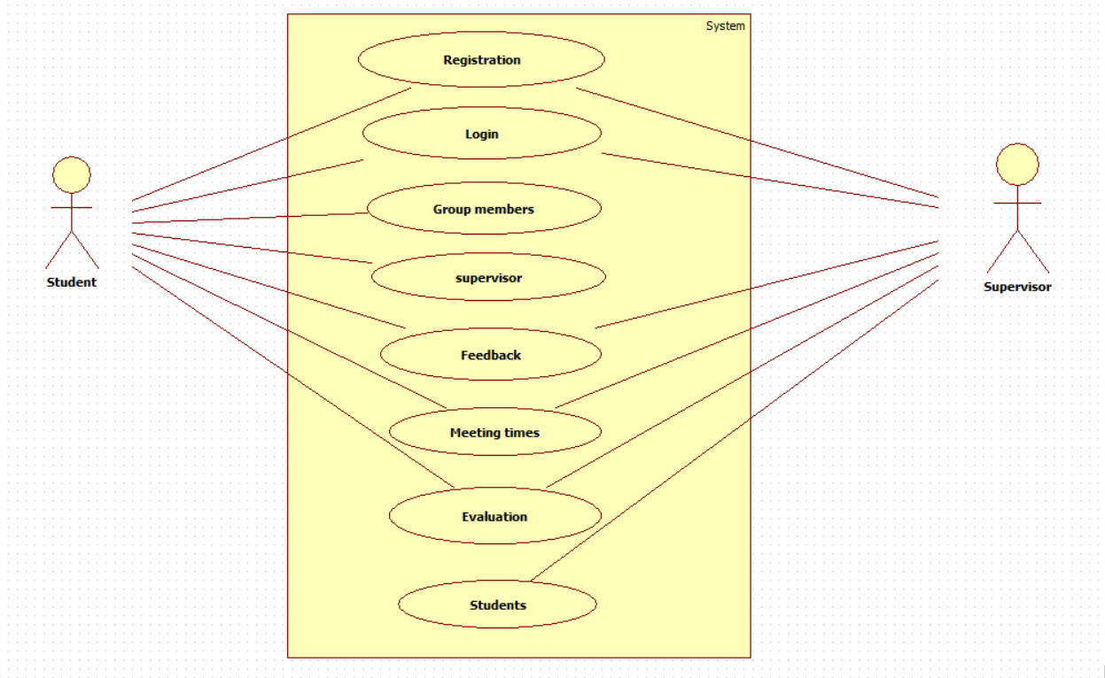

**REQUIREMENTS**

**4.1 Functional Requirements:**

1.The system will allow any new students to register themselves and create a new account.

2.The system will allow the supervisor to create new profile.

3.The system will allow the students to submit their tasks assigned.

4.The system will allow the supervisor to give feedbacks to the students on their evaluated project module.

5.The system helps students to align their performance if they are lacking.

6.The system allows to send and receive notifications.

**4.2 Software Requirements:**

1. Language: JavaScript, HTML, CSS

2. Database: MySQL

3. Tool: Visual Studio Code

4. Framework: React JS.

5. Operating System: Windows

**4.3 Non-Functional Requirements**

**4.3.1 Security**

Since the application stores the employee’s data including the login credentials and the images,

the security of the data should be maintained.

**4.3.2 Availability**

The application is available anywhere and at any time. It is not time bounded.

**4.3.3 Maintainability**

There should be a facility to store and maintain the website database if required. It shall also

provide backup.

**4.3.4 Reliability**

It is a reliable web application as it allows only the authenticated users by using authentication

modules.

**4.3.5 Performance**

system should be able to handle a certain number of concurrent users or process a certain amount of data within a specific time frame

**CONCLUSION**

Project management helps to detail what tasks will be accomplished who will be involved in completing the task. It can be used to manage the project and communicating timing and status including the task dairies, WBSs and Gantt charts.

It makes the student to complete the task on time and in correct manner.